Use Cases

for

**Fantastic 6 (F6) Direct Online Store**

**Version 1.0 approved**

**Prepared by Fulya Kocaman, Wangmo Tenzing, Vamshi Katipally, Abram Flores, Anthony Hernandez, Manthan Vasani**

**CPSC 541**

**4/18/2022**

**Revision History**

| **Name** | **Date** | **Reason For Changes** | **Version** |
| --- | --- | --- | --- |
| Fulya Kocaman | 4/18/2022 | Created | 1.0 |
|  |  |  |  |

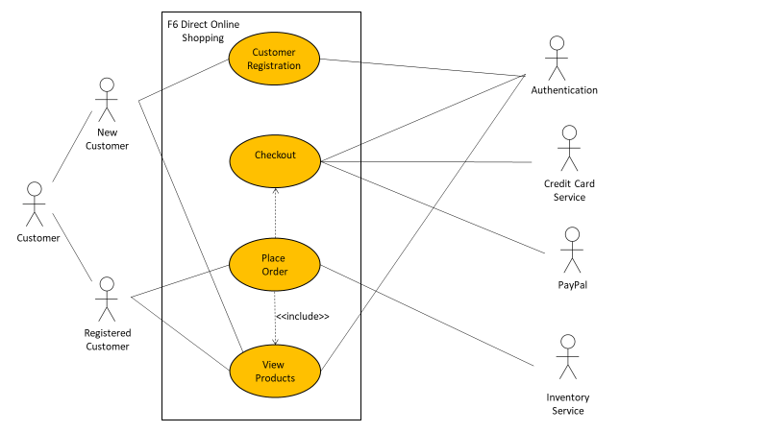

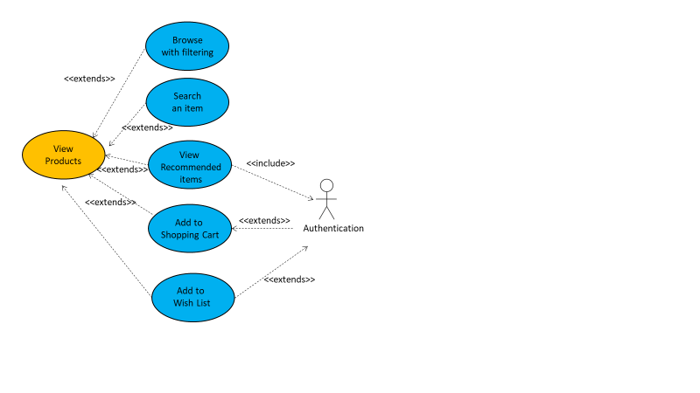

## Use Case ID and Name

ID and Name: UC-6: Place an order

## Author and Date Created

Created By: Fulya Kocaman Date Created: April 18, 2022

## Primary and Secondary Actors

Primary Actor: Customer Secondary Actor: F6 Direct Online Store System

## Trigger

A Customer indicates that they want to place an order.

## Description

A Customer accesses F6 Direct Online Store from either a home computer or a mobile application, checks out the shopping cart after viewing the items, adding them to the shopping cart, logging into the account or checking out as a guest, and placing the order to be picked up at the designated stores or delivered to their home or a specific location within a specified time window.

## Preconditions

PRE-1: Customer goes onto F6 Direct Online Store website.

## Postconditions

POST-1: Order is stored in F6 Direct Online Store System with a status of “Received”.

POST-2: Order is sent to the shipping department or a third party vendor.

POST-3: Inventory of available products is updated according to this order.

POST-4: Remaining delivery capacity for time windows is updated according to this order.

## Normal Flow

**6.0 Place an order**

1. Customer views product by searching for an item, browsing a catalog with added filters, or viewing items recommended for them.

2. F6 Direct Online Store System displays available product descriptions and deals of the day.

3. Customer adds new products to the shopping cart or wish list from the available list of items.

4. F6 Direct Online Store System displays a message indicating the item added.

5. Customer proceeds to checkout when the order is complete.

6. Customer registers to the website for the first time by choosing a unique username and password (continue normal flow) or checks out as a guest (skip step 7).

7. Customer enters their login information.

8. F6 Direct Online Store System displays ordered items, individual prices, and total price, including taxes and delivery charges if any.

9. Customer either confirms the order (continue normal flow) or requests to modify the order (return to step 2).

10. F6 Direct Online Store System asks Customer to provide shipping and billing information.

11. Customer selects a delivery date and specifies the delivery location.

12. Customer specifies the payment method.

13. F6 Direct Online Store System confirms acceptance of the order.

14. F6 Direct Online Store System sends an email to Customer confirming order details, price, and delivery instructions.

15. F6 Direct Online Store System stores the order, sends order information to the Inventory System, and updates available delivery dates.

## Alternative Flows

**6.1 Use promotions, coupons, or gift cards**

1. Customer asks to use an alternative payment method

2. Return to step 12 of normal flow.

**6.2 User session times out**

1. Customer places an order.

2. F6 Direct Online Store System informs the user that the session times out.

3. Return to step 6 of normal flow.

**6.3 Repeat one of the past orders as the new order**

1. Customer places one of the past orders they ordered before.

2. Return to step 5 of normal flow.

**6.4 Order multiple identical products**

1. Customer requests a certain number of identical products. (see 1.1.E1)

2. Return to step 5 of normal flow.

**6.5 Order multiple products**

1. Customer requests to order other products.

2. Return to step 1 of normal flow.

**6.6 Delivery dates not ideal**

1. Customer asks for pick-up instead of delivery at a designated store.

2. Return to step 12 of normal flow.

## Exceptions

**1.0.E1 Payment method rejected ending transaction**

1. F6 Direct Online Store System rejects the Customer’s specified payment method.

2a. If Customer cancels the order, then F6 Direct Online Store System terminates this use case.

2b. Else if Customer requests to change the payment method, then return to step 12 of normal flow.

**1.1.E1 Product out of stock**

1. F6 Direct Online Store System displays Customer that the product from there is no longer available.

2a. If Customer cancels the order, then F6 Direct Online Store System terminates this use case.

2b. Else if Customer asks to put the product in backorder, then return to step 5 of normal flow.

2c. Else if Customer requests to change the product, then return to step 1 of normal flow.

**1.2.E1 Unsuccessful login attempts**

1. F6 Direct Online Store System displays Customer that they reach the maximum number of attempts during logging in.

2a. If Customer cancels the order, then F6 Direct Online Store System terminates this use case.

2b. Else if Customer changes the user name/password after getting redirected by the F6 Direct Online Store System, then return to step 7 of normal flow.

## Priority

High

## Frequency of Use

Approximately 1,000 users, an average of one usage per day.

## Business Rules

None

## Other Information

1. Customer shall be able to cancel the ordering process at any time prior to confirming it.

2. Customer shall be able to view all purchases they ordered from the previous years and repeat one of those orders as the new order, provided that all items are available in the inventory.

3. After three consecutive unsuccessful login attempts, the user's account will be locked and must be reset by a system administrator.

4. Financing Department has access to all the credit/debit card companies and banks to confirm the e-payment given by customers.

5. Multiple customers from different locations shall be able to add items to the shopping cart simultaneously.

## Assumptions

Assume that the user has an access to reliable internet and a device to get connected to the F6 Direct Online Store’s website.

Use Case List

| ***Primary Actor*** | ***Use Cases*** |
| --- | --- |
| Customer | Place an order |
|  |  |

**UC-6: Place an Order**

| UC ID and Name: | UC-6 Place an order | | |
| --- | --- | --- | --- |
| Created By: | Fulya Kocaman | Date Created: | April 18, 2022 |
| Primary Actor: | Customer | Secondary Actors: | F6 Direct Online Store Inventory System |
| Trigger: | A Customer indicates that they want to place an order. | | |
| Description: | A Customer accesses F6 Direct Online Store from either a home computer or a mobile application, checks out the shopping cart after viewing the items, adding them to the shopping cart, logging into the account or checking out as a guest, and placing the order to be picked up at the designated stores or delivered to their home or a specific location within a specified time window. | | |
| Preconditions: | PRE-1: Customer goes onto F6 Direct Online Store website. | | |
| Postconditions: | POST-1: Order is stored in F6 Direct Online Store System with a status of “Received”.  POST-2: Order is sent to the shipping department or a third party vendor.  POST-3: Inventory of available products is updated according to this order.  POST-4: Remaining delivery capacity for time windows is updated according to this order. | | |
| Normal Flow: | **6.0 Place an order**  1. Customer views product by searching for an item, browsing a catalog with added filters, or viewing items recommended for them.  2. F6 Direct Online Store System displays available product descriptions and deals of the day.  3. Customer adds new products to the shopping cart or wish list from the available list of items.  4. F6 Direct Online Store System displays a message indicating the item added.  5. Customer proceeds to checkout when the order is complete.  6. Customer registers to the website for the first time by choosing a unique username and password (continue normal flow) or checks out as a guest (skip to step 7).  7. Customer enters their login information.  8. F6 Direct Online Store System displays ordered items, individual prices, and total price, including taxes and delivery charges if any.  9. Customer either confirms the order (continue normal flow) or requests to modify the order (return to step 2).  10. F6 Direct Online Store System asks Customer to provide shipping and billing information.  11. Customer selects a delivery date and specifies the delivery location.  12. Customer specifies the payment method.  13. F6 Direct Online Store System confirms acceptance of the order.  14. F6 Direct Online Store System sends an email to Customer confirming order details, price, and delivery instructions.  15. F6 Direct Online Store System stores the order, sends order information to Inventory System, and updates available delivery dates. | | |
| Alternative Flows: | **6.1 Use promotions, coupons, or gift cards**  1. Customer asks to use alternative payment method  2. Return to step 12 of normal flow.  **6.2 User session times out**  1. Customer places an order.  2. F6 Direct Online Store System informs the user that the session times out.  3. Return to step 6 of normal flow.  **6.3 Repeat one of the past orders as the new order**  1. Customer places one of the past orders they ordered before.  2. Return to step 5 of normal flow.  **6.4 Order multiple identical products**  1. Customer requests a certain number of identical products. (see 1.1.E1)  2. Return to step 5 of normal flow.  **6.5 Order multiple products**  1. Customer requests to order other products.  2. Return to step 1 of normal flow.  **6.6 Delivery dates not ideal**  1. Customer asks for pick-up instead of delivery at a designated store.  2. Return to step 12 of normal flow. | | |
| Exceptions: | **6.0.E1 Payment method rejected ending transaction**  1. F6 Direct Online Store System rejects the Customer’s specified payment method.  2a. If Customer cancels the order, then F6 Direct Online Store System terminates this use case.  2b. Else if Customer requests to change the payment method, then return to step 12 of normal flow.  **6.1.E1 Product out of stock**  1. F6 Direct Online Store System displays Customer that the product from there is no longer available.  2a. If Customer cancels the order, then F6 Direct Online Store System terminates this use case.  2b. Else if Customer asks to put the product in backorder, then return to step 5 of normal flow.  2c. Else if Customer requests to change the product, then return to step 1 of normal flow.  **6.2.E1 Unsuccessful login attempts**  1. F6 Direct Online Store System displays Customer that they reach the maximum number of attempts during logging in.  2a. If Customer cancels the order, then F6 Direct Online Store System terminates this use case.  2b. Else if Customer changes the user name/password after getting redirected by the F6 Direct Online Store System, then return to step 7 of normal flow. | | |
| Priority: | High | | |
| Frequency of Use: | Approximately 1,000 users, an average of one usage per day. | | |
| Business Rules: | None | | |
| Other Information: | 1. Customer shall be able to cancel the ordering process at any time prior to confirming it.  2. Customer shall be able to view all purchases they ordered from the previous years and repeat one of those orders as the new order, provided that all items are available in the inventory.  3. After three consecutive unsuccessful login attempts, the user's account will be locked and must be reset by a system administrator.  4. Financing Department has access to all the credit/debit card companies and banks to confirm the e-payment given by customers.  5. Multiple customers from different locations shall be able to add items to the shopping cart simultaneously. | | |
| Assumptions: | Assume that the user has an access to reliable internet and a device to get connected to the F6 Direct Online Store’s website. | | |